Cohort C
2017 &-2018 Schedule

Year 2: Biblical Foundations
Face- to-face meetings on third Saturday of each month. Each meeting 9:00 AM-3:00 PM

Hermeneutics & Pentateuch
Instructor: Rev. Barry W. Szymanski, J.D.
2 Face-to-Face Seminars: Sept 16 and Oct 21, 2017
Location: First Congregational Church, Wauwatosa
++++++++++++++++++++++++++++++++++++
The Historical Books
Instructor: Rev. Randall Kohls
1 Face-to-Face Seminar: Nov 18, 2017
Location: Faith Community Church, Franklin
++++++++++++++++++++++++++++++++++++
Wisdom Literature
Instructor: Rev. Dr. Cindy Bacon Hammer
1 Face-to-Face Seminar: Dec 16, 2017
Location: Heritage Congregational Church, Madison
++++++++++++++++++++++++++++++++++++
Prophets & Intertestamental Period
Instructor: Rev. Dr. Sue LeFeber
2 Face-to-Face Seminars: Jan 20 and Feb 17, 2018
Location: Faith Community Church, Franklin
++++++++++++++++++++++++++++++++++++
Gospels
Instructor: Rev. Joy Baumgartner
1 Face to Face Seminar: March 17, 2018
Location: Faith Community Church, Franklin
Acts
Instructor: Rev. Dr Stu Merkel
1 Face-to-Face Seminar: April 21, 2018
Location: Faith Community Church, Franklin
+++++++++++++++++++++++++++++++
Pauline Epistles
Instructor: Rev. Dr. Mark McAnlis
1 Face-to-Face Seminar: May 19, 2018
Location: Faith Community Church, Franklin
+++++++++++++++++++++++++++++++
General Epistles & Revelation
Instructor: Rev. Dr. Mark Dieter
1 Face-to-Face Seminar: June 16, 2018
Location: Lancaster Congregational Church, Lancaster

Year 3: Ministry Applications
September 2018 -May 2019
Topics include Church History; Evangelism; Church administration; Pastoral Care; Worship; Teaching and Preaching; Discipleship; and Worship

Interested in joining Cohort C? Whether continuing your journey from Year 1, or just starting out to advance your knowledge of Biblical Foundations, you are welcome to join Cohort B. Fill out an application and send it to:
Polly Bodjanac
pollybodjanac@gmail.com
920-655-3597

Applications due by August 15, 2017
What about Credentialing?
Congregationalists have long held that ordination and credentialing lies with the local church. Completion of this program does not promise either. The program is designed to help train you to fulfill your calling in whatever ministry capacity you and your church deem fit. Though a
certificate is presented to the student at the conclusion of each year, ordination, licensing, and empowerment are conducted by the local church.

Am I called to Lay-Ministry?
“Lay-ministry” can be a confusing term. Within the Congregational Tradition, there are lay people who have been called by God to assume the role of a vocational pastor of a congregation. Formal training programs aid in preparation for such a calling. Yet, on the other hand, Congregationalists recognize the Bible’s teaching of the priesthood of all believers. We own a tradition of “an every-member ministry” in addition to the vocational ministry. This training program is for both types of lay-ministry in our churches. The first two years of this program are designed for all who minister: those called to be Lay-Ministers and those called to be lay people ministering in other capacities (Sunday school teachers, deacons, trustees, custodians, and even pew warmers). The third year, though not exclusive, is more specific to the Lay-Minister in a pastoral role.

Preparation for Christ Centered Ministry
The Leadership and Lay-Minister Training Program seeks to equip individuals to carry out the work of ministry. The program entails three successive one-year modules completed in a cohort. A mixture of individual study, reading and reflection is combined with monthly gatherings held at various locations of hosting WCA Churches.

Year 3 Ministry Applications
The third year is for application of ministry techniques in teaching and preaching, pastoral care, worship and church administration. Those called to be official lay-ministers will work with a settled pastor through this last year.

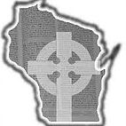

What is the Cost?
The fee is waived for returning students from Year 1. New incoming students will pay a fee of $25 to help with administrative needs. All students, returning and incoming will incur other expenses such as: books, lunch costs at the Saturday gatherings, and travel to host churches.

Applications due by August 15, 2017

What is Necessary?
Students will need:
Open hearts, minds & teachable spirits
A yearly covenant-commitment
College level literacy
Computer and Internet access
Transportation to face-to-face Saturdays
Church support or participation

For more information and/or
an application to the program please contact:
Polly Bodjanac
pollybodjanac@gmail.com
or check the WCA website
www.wiscongregational.net

We look forward to walking with you to discover God’s plan and will for you and your ministry.
Wisconsin Congregational
Association
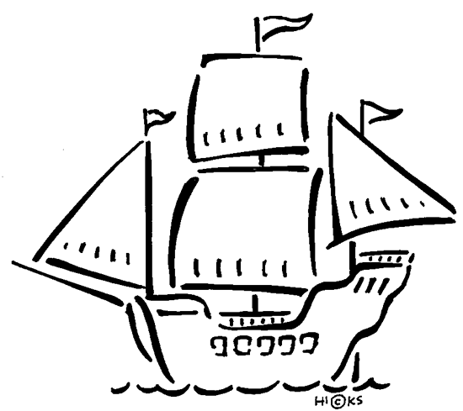

LEADERSHIP &
LAY-MINISTER
TRAINING PROGRAM

Cohort C
Sept 2016-
June 2019

